 | Journal of Basic and Environmental Sciences 3 (2016) 98– 106 | ISSN 2356-6388
Research Article Open Access
Sensitive, Direct and Rapid Spectrophotometric Determination of Loxoprofen through Ion Associate Complex Formation and First Derivative Methods
Enas A. Amer², Islam M. I. Moustafa*¹ and Hana S. Hanafy²
1 Chemistry Department, Faculty of Science, Benha University, Benha, Egypt.
2 National Organization for Drug Control and Research, Giza, Egypt
- Corresponding author; e-mail: islamshahin84@ outlook.com. Tel: 0201227535354
Received: 25 Aug. 2016, In Revised form: 5 Sept. 2016, Accepted: 5 Sept. 2016, Available online: 1 Oct. 2016.
Abstract
Two simple, accurate and sensitive methods had been developed and validated for determination of loxoprofen (LOXO) in pure and dosage forms. The first method is based on the formation of ion-associate complexes between the drug and arsenazo I (ARS I) or Bromophenol blue (BPB) to give colored products maximally absorbed at 535 and 640 nm with the two reagents, respectively. Different factors affecting the reaction between the drug and the two reagents were carefully studied and optimized. Under the optimum conditions, linear relationships with good correlation coefficients (0.9993 and 0.9988) were found between absorbance and concentrations of the drug in the concentration range 2.70-91.4 and 2.8-107.3 µgml⁻¹ for the two reagents, respectively. The assay limits of detection and quantification were 1.57 and 1.11 µgml⁻¹, 2.51 and 2.32 µgml⁻¹, respectively. In the second method, first derivative spectrophotometry was used where it was found that LOXO can be determined by measuring the amplitude at 232 nm. The methods were validated, in terms of accuracy and precision and the results were satisfactory. The proposed methods were successfully applied to determination of the investigated drug in pure and pharmaceutical dosage forms without interference from the common excipients. The results obtained by the proposed methods were comparable with those obtained by reference methods
Keywords: loxoprofen, spectrophotometric determination, ion pair complexes, first derivative spectroscopy.
- Introduction

Loxoprofen is a non-steroidal anti-inflammatory, used to treat pain, swelling, fever and inflammation associated with musculoskeletal and joint disorders.
Literature search has indicated that several techniques such as UV - visible spectroscopy [1- 4], high performance liquid chromatography [5-11], NIR [12] and chemiluminescence methods [13] were proposed for determination of loxoprofen. These techniques require sophisticated instruments and expensive reagents. The formation of ion-associate complexes between organic dyes and different drug compounds is one of the techniques available for determination of pharmaceutical compounds [14 – 20]. However, a more rapid, sensitive, selective, accurate, and precise methods are needed for its determination.
This paper describes the development of two spectrophotometric methods that can be used in laboratories without modern and expensive instrumentation such as that required for gas chromatography or HPLC. The first method involves the formation of ion-associate complexes of loxoprofen (LOXO) with arsenazo I (ARSI) or bromophenol blue (BPB) as chromogenic reagents, while the second method uses of first derivative spectroscopy for determination of drug. The proposed procedures were applied successfully for determination of loxoprofen in pure and in pharmaceutical preparations with good accuracy and precision.
- Experimental
  - Instrumentation
- All absorption measurements were made by using a Shimadzu UV1601 double beam UV-VIS spectrophotometer loaded with Shimadzu UV-Prob Version 1.10 software and interfaced to Pentium-4 computer and Canon-810 laser printer to record the spectra and perform subsequent calculations of their derivatives (NODCAR). The spectrophotometric measurements were made at wavelength range 200-600 nm using 10 mm quartz matched cells. The derivative spectra were recorded with a fast scan speed, sampling interval =1.0 and slit width =2.0 nm.
- pH meter Jenway 3510 (NODCAR).
- Electric Balance (RADWAG) XA60/220/X (NODCAR).

  - Drug solutions:
The pharmaceutical compound, loxoprofen (LOXO), was obtained from Egyptian Group for Pharmaceutical Industries Company (EGPI), Elobor City, Egypt. Its IUPAC name is (RS)-2-{4-[(2-oxocyclopentyl) methyl] phenyl} propanoic acid and the molecular weight is246.30 g/mol. It has the following structural formula:
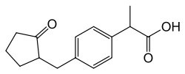
Stock solutions of loxoprofen were prepared as (1mg/ml) in bidistiled water for the both methods and solution of 10⁻³ M for continues variation methods.
Pharmaceutical dosage forms:
- Roxonin tablet (maltipharma- Egypt, manufactured by sajapharma, jaddah, soudi Arabia) labeled to contain 60 mg loxoprofen sod.per tablet.
- Roxogesic tablet (EGYP.GP /Tag pharma, Egypt labeled to contain 60 mg loxoprofen sod per tablet.
  - Reagents:
The analytical reagents used in the present work are arsenazo I (ARZ I) and Bromophenol blue (BPB). They have the following structural formula:
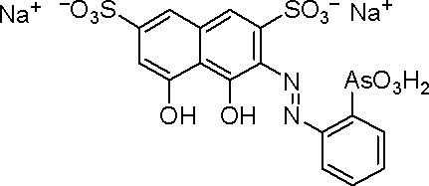
Arsenazo I (ARZ I)
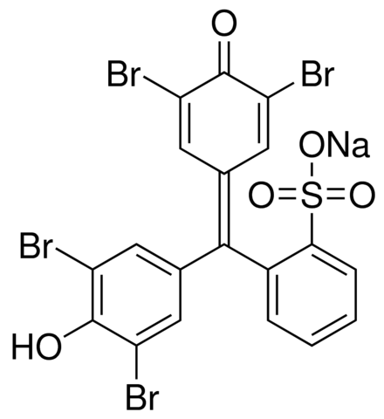
Bromophenol blue (BPB)
Stock solutions of 10⁻³ M of the reagents were prepared in ethanol. Universal buffer solutions of different pH values (2.04-12.06) were prepared [21].
  - Preparation of pharmaceutical dosage form samples
A quantity of finely grounded tablet powder equivalent to 50 mg of LOXO was accurately transferred into 100 ml calibrated flask, 60 ml of bidistilled water was added and shaken for 10 minutes. The volume was then made to the mark, mixed well and filtered using a Whatman No. 42 filter paper. The first 10 ml portion of the filtrate was discarded and the filtrate was diluted appropriately by transferred 1ml into 10 ml calibrated flask to get 50 µg/ml of LOXO for assay by the recommended method
  - General Procedure
    - Method I
In a 10 ml volumetric flask, an aliquot drug solution containing 50 µg/ml of LOXO is added to 2.0 ml of 1x10⁻³ M reagent solution followed by 3.0 ml universal buffer solution at the optimum pH. The mixture was diluted to volume with bidistilled water and the solution was allowed to stand for 5.0 min at room temperature (25±2ºC). The absorbance was then measured at the recommended wavelength using a reagent blank similarly prepared without drug. The concentration of the drug is then determined from the calibration curve previously constructed under the optimum conditions.
Stoichiometric Ratio
The stoichiometry of the ion–associate complexes was studied using the mole ratio and continuous variation methods [22, 23].

    - Method II
Different aliquots of LOXO standard stock solution (0.02 – 2.00 ml) were transferred into series of 10 ml volumetric flasks so as to obtain solutions over concentration rang of (2 –200μg/ml). The first derivative spectra were recorded and the absorbance at maximum amplitude (232 nm) is plotted against concentration.
- Results and Discussion
  - Determination of loxoprofen through ion associate complex
Preliminary investigations revealed that loxoprofen reacts directly with each of the reagents (ARS I) and (BPB) to produce soluble ion-associate complexes exhibiting absorption maxima at 535 and 640 nm, respectively. The presence of the ion-associate complexes was supported by the bathochromic shift observed from 510 and 605 nm for the reagents to 538 and 640 nm for the complexes, respectively. Representative example for, eg. LOXO –BPB ion pair is shown in fig (1).
0
2.5
1
2
500
750
600
700
Abs
Wavelength [nm]
A; (_.._..): BPB vs. buffer, B; (__) BPB + LOXO vs. buffer and C; (_._) Mixture B vs A
Fig (1): Difference curves of LOXO - BPB complex
The optimum conditions favoring the formation of colored complexes were attained by studying the different variables affecting the reaction as follows.
    - Effect of pH
Various aqueous buffers (acetate, borate, phosphate, thiel, and universal buffers) with different pH values were tested to establish the best buffer media. Universal buffer solutions at pH range 2.04 -12.06 gave the best results; the optimum pH values giving maximum absorbance for LOXO with ARZ I and BPB are 11.62 and 8.66, respectively. Moreover, the optimum volume of buffer solution was examined and found to be 3.0 ml in a total volume of 10ml.
    - Effect of time and temperature
Sample solutions containing loxoprofen and the blank were treated identically with the reagent and buffer for different times and at different temperatures. The results obtained indicated that the ion-associate complexes were formed instantaneously at room temperature (25 ± 2ºC). The absorption spectra and color intensities were not altered by varying the temperature up to 40ºC, above which the absorbance decreased by 10 % for every increase of 5.0ºC. The experiments showed that complexes are formed within few minutes (5 minutes) after mixing drug with reagent in the buffered media and remain stable for about 6 hours. It was found also that The absorbance remained stable for about 15 hrs, then it began to decrease slowly.
    - Effect of reagent concentration
When various concentrations of (ARSI) and (BPB) were added to a fixed concentration of loxoprofen at 50 µg/ml, 2.0 ml of 10⁻³ M reagent solution was found to be enough to develop the color to full intensity.
    - Stoichiometric ratio
The stoichiometry of the ion-associate complexes was investigated at the optimum pH values by applying the mole ratio and continuous variation methods. The results indicated the formation of a 1:1 ion-associate complex. The logarithmic stability constants were calculated from the spectral data of both methods [24, 25] and are shown in Table (1).
    - Validation
Under the optimum experimental conditions described, standard calibration curves for loxoprofen with ARS I and BPB were constructed by plotting absorbance versus concentration. Conformity to Beer's law was evident in the concentration range of the final dilution, (Table 1). The linear regression equation for the method is also shown in the table. The correlation coefficients are 0.9993 and 0.9988 for the two reagents, respectively indicating good linearity. For more accurate results, Ringbom optimum concentration ranges were obtained by plotting transmittance percent versus the logarithmic value of the concentration in [µg/ml]. Values for mean molar absorptivity and Sandell sensitivity were also calculated and are collected in Table 1.

Table (1): Spectrophotometric cumulative data for loxoprofen (LOXO) using arsenazo I (ARS I) and bromophenol blue (BPB) as chromophoric reagents
ParameteR | ARS I | BPB
pH | 11.62 | 8.66
λ_{max} (nm) | 535 | 640
Beer's limits (µg/ml) | 2.70-91.4 | 2.8-107.3
Ringbom range (µg/ml) | 70-2.0 | 60-2.19
Molar absorptivity (x10⁴)(l mol⁻¹ cm⁻¹) | 8.43 | 2.72
Sandell sensitivity(µg cm⁻²) | 13.34 | 9.06
Intercept (b)* | -0.013 | -0.017
Slope (m)* | 0.0084 | 0.0271
Correlation coefficient (r) | 0.9993 | 0.9988
Stability constant** | 5.87 | 6.62
RE % | 0.19 | 0.23
LOD(µg/ml) | 1.57 | 1.11
LOQ(µg/ml) | 2.51 | 2.32
* Linear regression equation: Y = mX + b
** Mean value of Molar ratio and continuous variation methods.

    - Accuracy
The accuracy of the proposed method was determined by analyzing 5 replicate samples, each containing loxoprofen at 25,50,75 µg/ml for ARS I and BPB in the final assay solution, (Table 2).

Table (2): Evaluation of the accuracy and precision of the proposed method for the determination of loxoprofen .
Recovery % | Found *(µg/ml) |  | Taken (µg/ml) | Reagent
99.76 | 24.94 |  | 25 | ARZ I
99.8 | 49.9 |  | 50 | ARZ I
100.13 | 75.1 |  | 75 | ARZ I
0.2 | SD |  | 99.89 | Mean
100.36 | 25.09 |  | 25 | BPB
100.14 | 50.07 |  | 50 | BPB
99.8 | 74.85 |  | 75 | BPB
0.28 | SD | 100.1 |  | Mean
* Average of five replicates

    - Analytical Applications
The pharmaceutical formulations Roxonin tablet (labeled to contain 60 mg loxoprofen sod. per tablet) and Roxogesic tablet (labeled to contain 60 mg loxoprofen sod per tablet) were analyzed by the proposed method, and the accuracy of the method was confirmed by comparison of the results with those obtained earlier. The standard additions method was used, in which variable amounts of the pure drug were added to the previously analyzed portion of the pharmaceutical formulations. Results (Table 3) confirm that the proposed method is highly sensitive; therefore, it can be used easily for routine determination of LOXO in its pure form and in its pharmaceutical formulations.

Table (3): Determination of LOXO in dosage forms applying standard addition technique using arsenazo I (ARS I) and BPB as chromophoric reagents.

Dosage forms | Taken  (µg/ml) | ARS I |  |  | BPB
Dosage forms | Taken  (µg/ml) | Added  µg/ml | Found*  µg/ml | Recovery  (%) | Added  µg/ml | Found*  µg/ml | Recovery  (%)
Roxonin tablet | 40 | 0 | 39.98 | 99.95 | 0 | 40.02 | 100.05
Roxonin tablet | 40 | 20 | 60.09 | 100.15 | 20 | 60.01 | 100.01
Roxonin tablet | 40 | 40 | 79.89 | 99.86 | 40 | 79.94 | 99.92
Roxonin tablet | 40 | 50 | 89.98 | 99.97 | 50 | 90.51 | 100.56
Mean |  |  |  | 99.98 |  |  | 100.13
SD |  |  |  | 0.12 |  |  | 0.28
Roxogesic tablet | 40 | 0 | 40.1 | 100.25 | 0 | 39.72 | 99.3
Roxogesic tablet | 40 | 20 | 59.89 | 99.81 | 20 | 59.89 | 99.81
Roxogesic tablet | 40 | 40 | 80.05 | 100.06 | 40 | 79.8 | 99.75
Roxogesic tablet | 40 | 50 | 90.1 | 100.11 | 50 | 90.02 | 100.02
Mean |  |  |  | 100.05 |  |  | 99.72
SD |  |  |  | 0.18 |  |  | 0.30

* Average of five determinations.

  - Determination of loxoprofen using first derivative spectrophotometric method.
From the first derivative studies (Fig. 2), it was found that LOXO can be determined by measuring the amplitude at 232nm.
The plot between the absorbance at maximum amplitude (232 nm) and concentration shows that linear relationship is obtained over the concentration rang (5 –100 μg/ml) at (¹D ₂₃₂) and the following regression equation was obtained from the graph .fig (3):
¹D₂₃₂ = 0.024 C_{(µg/ml)} + 0.027, R² = 0.9990 (1)
Where ¹D₂₃₂ is the first derivative amplitude value at 232 nm, C is the concentration in µg/ml and R² is the regression coefficient.

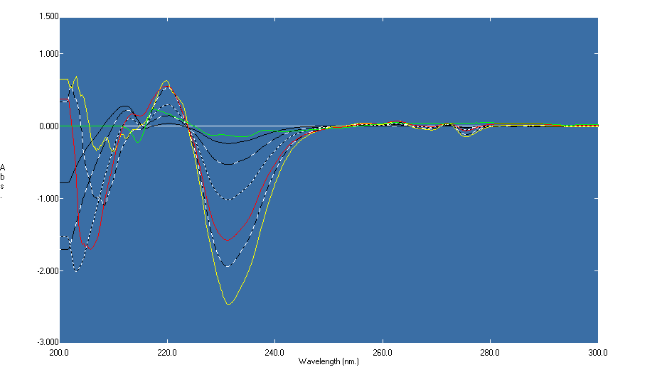

Fig (2): The first derivative spectra of LOXO (the maximum amplitude at 232 nm) (¹D ₂₃₂).

    - Determination of LOXO in bulk powder.
A series of solutions over concentration rang 20-60 µg/ml of LOXO were prepared and their absorption spectra were recorded. The recovered concentrations were calculated using the regression equation(1)
    - Determination of LOXO in its pharmaceutical formulations.
Ten Roxonin tablets were grinded and mixed well, then an accurately weight of powder equivalent to 100mg of LOXO was taken and transferred to 100 ml volumetric flask followed by 80 ml bidistilled water and sonicated for 15 min. The volume was made up to 100 ml then the solutions were filtered through a dry filter paper and first 10 ml of the filtrate was rejected.
A series of solutions over concentration rang (40- 80 µg/ml) of LOXO were prepared and analyzed using the recommended procedure. The data are cited in Table (4)

Fig (3): Calibration curve for determination of LOXO using ¹D at 232nm.
Table (4): Determination of LOXO in Roxonin tablets using the first derivative spectrophotometric method (¹D₂₃₂).
Recovery% |  | Found*(ug/ml) |  | Taken (ug/ml)
Added | tablet | Added | tablet | added | tablet
99.56 | 99.27 | 19.91 | 39.71 | 20 | 40
99.98 | 99.16 | 40.00 | 39.67 | 40 | 40
100.90 | 99.06 | 60.54 | 39.62 | 60 | 40
100.15 | 99.68 |  |  |  | Mean
1.09 | 0.72 |  |  |  | S.D
* Average of five determinations.

3.2.3. Accuracy
Different concentrations within the linearity range of LOX were analyzed in bulk powder to check the accuracy of the results. The mean percentage recoveries ±SD were100.84 ± 0.71 at 232nm
3.2.4. Precision:
The precision of the analytical procedure for both intra- and inter-day variations expressed as the coefficient of variation and good results were obtained, table (5).
Statistical comparison of these results with those obtained by applying the reported methods for LOXO show that the calculated t-and F-values did not exceed the theoretical values indicating no significant difference between the proposed methods and the reported methods, table (6).

Table (5): Intra –day validation for determination of LOXO at 232 nm ¹D methods.
Conc.µg/ml | Intra-day assay
Conc.µg/ml | Recovery % ±SD | Cv%
Conc.µg/ml | ¹D ₂₃₂ | ¹D ₂₃₂
10 | 99.33± 0.421 | 0.424
20 | 99.52 ± 0.235 | 0.236
30 | 100.21 ±0.763 | 0.761

Table (5) (cont.): Iner –day validation for determination of LOXO at 232 nm ¹D methods.
Conc.µg/ml | Inter-day assay
Conc.µg/ml | Recovery % ±SD | Cv%
Conc.µg/ml | ¹D ₂₃₂ | ¹D ₂₃₂
8 | 99.55± 0.471 | 0.473
16 | 99.61 ± 0.331 | 0.332
24 | 99.91 ±0.740 | 0.741

Table (6): Statistical analysis for determination of LOX using Ion-association and derivative spectrophotometric (¹D) methods compared with their reported methods.
Item | ARZ I | BPB | ¹D | Reported method[26]
Mean± S.D | 99.89± 0.20 | 100.1±0.28 | 100.84±0.71 | 100.35±0.49
%R.S.D. | 0.2 | 0.279 | 0.704 | 0.488
Variance | 0.04 | 0.078 | 0.504 | 0.24
S.E | 0.089 | 0.125 | 0.318 | 0.219
t-test | 1.94(2.31)* | 0.99(2.31)* | 1.27(2.31)* | -
F-test | 6.0(6.4)* | 3.06(6.4)* | 2.11(6.4)* | -

*Value in parentheses are the tabulated values of t and F at p= 0.05
4. Conclusions

Two spectrophotometric methods for the determination of loxoprofen were proposed. The first depends on the formation of highly colored ion pair complex with two chromophoric reagents; arsinazo I and bromophenol blue which absorb maximally at 535 and 640 nm, respectively. When the results obtained with the proposed method were compared with those obtained earlier [2,3], they showed a better sensitivity and higher accuracy for the non-extractive method, which required less time and had a lower range for micro determination. The proposed method is highly precise and is simpler and less time consuming than various HPLC methods [5-11]. Moreover, the proposed method could be used for routine determination of LOXO in pure form or in pharmaceutical formulations.
The second method utilizes the first derivative spectroscopy for the determination. The proposed methods are simple, less time consuming, and sensitive. They were advantageous over other reported visible spectrophotometric methods with respect to their higher sensitivity and selectivity. No interference from associated excipients and additives were observed. The proposed methods can be used for routine analysis and quality control laboratories for the determination of loxoproen in raw materials and in pharmaceutical formulations.

References

- S. Choi, S. Kim, J. J. Ryoo and K. Lee; J.Inclusion phenomena and macrocyclicChem., 40(1):139-146(2001).
- L.I Jin-hong; Progress in Modern Biomedicine; 1, (2008).
- D.Ying, G. Limin, Z. Shihuaand and B.O.YAO; China Modern Medicine,14, 56-59 (2010).
- JIANG Zong-Jie; “FujianHuitian Biological Pharmacy Co.Ltd, Sanming 365000, China” Strait Pharmaceutical Journal, 6 (2010).
- K.S. Choo, I.W. Kim, J.K. Jung, Y .G.Suh,S.J. Chung , M.H. Lee and C.K. Shim;J Pharm Biomed Anal, 25(3-4):639-50 (2001).
- H. Kanazawa , A. Tsubayashi, Y. Nagata, Y. Matsushima, C. Mori, J. Kizu and M. Higaki;J. Chromatography A,948(1–2): 303–308(2002).
- H. Cho, C. Park and Y. Lee ;J. Chromatography (B) , 835 (1–2): 27–34(2006).
- T. Murakami ,T. Kawasaki , A. Takemura, N. Fukutsu,N. Kishi and F. Kusu;Chromatogr(A), 1208(1-2):164-74(2008).
- H.Lee, H. Y. Ji, D.H.Sohn, S.Kim, Y. B. Lee and H.S. Lee; Biomedical Chromatography, 23(7): 714–718(2009).
- R. Nanthakumar , V. Prabakaran, K. Chitra and C. Uma Maheswara Reddy; Arabian J Chemistry (Available online 21 July 2011).
- M.Kashif, N. Rahman, H. A. Idrees, I. Aslam, S. M. Iqbal and R. Mustafa; Lat. Am. J. Pharm. 32 (4): 587-92 (2013).
- H. I. Shin, B. H. Kim, H. S. Chang, C. H. Park and C. I. Kim; Korean J Urol, 52(4):265-268(2011).
- L. Wang, Y. Tang and Y. Liu; J. Pharm. Analysis, 1(1):51–56(2011).
- A. S. Amin and Y. M. Issa; Mikrochim. Acta130, 173-179(1999)
- H.Kanazawa, A.Tsubayashi, Y.Nagata , Y. Matsushima, C.Mori , J.Kizu and M.Higaki; J. Chromatography A,948(1-2):303-308(2002).
- G. H. Ragab and A. S. Amin; Spectrochim.Acta (A) 60,973-978(2004).
- L. Wang, Y. Tang and Y. Liu; J. Pharm. Analysis, 1(1):51–56(2011).
- H. I. Shin, B. H. Kim, H. S. Chang, C. H. Park and C. I. Kim; Korean J Urol, 52(4):265-268(2011).
- P.Venkatesan, V.S Janardhanan,C. Muralidharan and K.Valliappan;ActaChim Slov,59(2):242-8 (2012).
- M.Hirosawa , T.Sambe, N.Uchida, Xiao, P. Lee, K. Sato and S.Kobayashi; Japanese J. Ophthalmology, 59 (5), 364-371(2015).
- H. T. S. Britton; "Hydrogen Ions", 4th Ed., Chapman and Hall, London, UK, p. 453(1952)
- J.H.Yoe and A.L.Jones; Ind.Eng.Chem.J.Anal. 16th Ed., 111(1944).
- P.Job; Camp.Rend.180, 928(1925); Anal.Chem.9, 133(1928); Anal.Chem.6, 97(1935).
- W.C.Vosburgh and C.R.Cooper; J.Amer.Chem.Soc. 63, 437(1941).
- R.M.Issa and M.M.El-Essawy; Z.Phys.Chem. (Leipzig), 96, 253(1973).
- M.Kashif, N. Rahman, H. A. Iderrs, I. Aslam, S. M. Iqbal and R. Mustafa; Lat. Am. J. Pharm. 32 (4):587-92,(2013)

